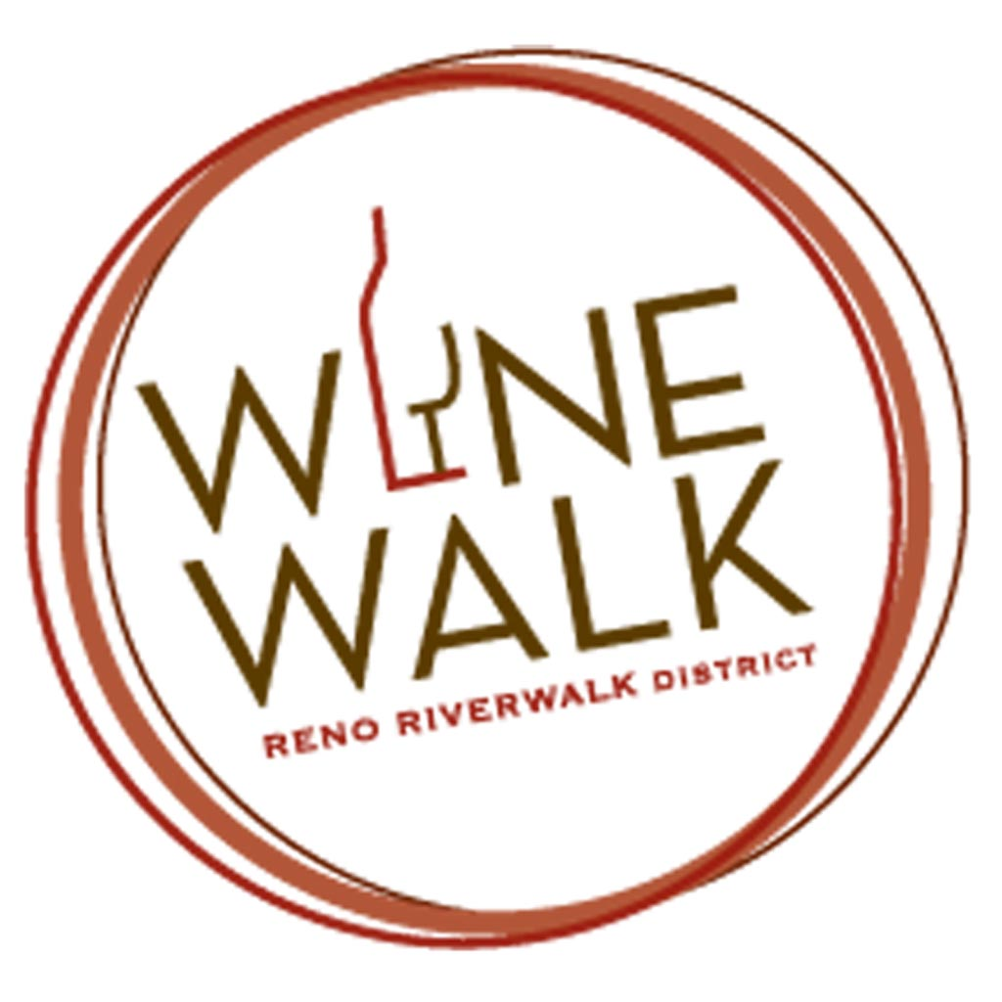

Community Partnership Program for monthly
Wine Walks Application Date:______________________________

The Wine Walk occurs during the third Saturday of Every Month 2pm- 5pm

Funds raised from the Wine Walk are used to promote the RWMA area to locals and tourists. Realizing the importance of giving back to the community, the RWMA supports deserving nonprofit Organizations as partners in selected Wine Walks throughout the year that fit within the RWMA mission and marketing goals.

CRITERIA for nonprofit entity:
1. Recognized local 501(c)3 as designated by the IRS. Nonprofit must provide a copy of their designation letter to the RWMA and complete the application.
2. Excellent reputation in the community for providing effective and economical programming.
3. Capability and staff (paid or volunteers) to partner with the RWMA in promoting and manning the event.

PROCEDURE:
1. RWMA merchant(s) recommends nonprofit to the members. Members agree to support.
2. Nonprofit agrees to partner.
3. Wine Walk committee meets with nonprofit to review procedure. Suggest at least 3 months in advance of date chosen.
4. Nonprofit is allowed to have donor boxes at all willing merchants along with a volunteer/staff to man the box and distribute information about the nonprofit. Merchants are not responsible for donor boxes.
5. The Wine Walk map will state that a portion of funds raised during the Wine Walk is being donated to the nonprofit with a brief statement and contact information about the non-profit .
6. RWMA welcomes nonprofit ideas to promote the Wine Walk before and during the event. All press releases, posters, signage, t-shirts, postcards, etc. created by the nonprofit for the Wine Walk must be approved through the Wine Walk committee before release. If applicable, RWMA expects to be included in the nonprofit’s newsletter, website event listings, etc.
7. The nonprofit will receive a portion of he proceeds with a maximum of $400.
8. A check will be issued to the nonprofit within three weeks after the Wine Walk date accounting for all glasses sold.

I agree to the above stipulations (Signature) ________________________________________________________________________ Date _____________________

Please print name __________________________________________________________________________________

NONPROFIT NAME_________________________________________________________________________________ Community Partnership Program for monthly Wine Walks Application Date:______________________________

Submissions can be e-mailed to Valerie@renoriver.org
Or mailed to The Riverwalk Merchants Assn., P.O. Box 1606, Reno, NV 89505 USA

Submissions are reviewed by the members of the Riverwalk Merchants Association on a monthly basis.
If the submission is accepted a member of the Executive Committee and at that time will contact you establish the necessary items, dates, references and additional marketing materials required for the event. The Wine Walk occurs during the Third Saturday of Every Month 2pm- 5pm

NON-PROFIT NAME (to be used for publicity) ____________________________________________________________________________________________________
Contact Name:________________________________________________________________________________________ Title:________________________________________________________________________
Secondary Contact Name:____________________________________________________Address:_______________________________________________________________________CIty:________________________________State:___________Zip:___________Phone #:_______________________________________Fax #:________________________________________e-mail address:_______________________________________________ Website (not required):_______________________________________________________________________

Incorporation date ___________________ EIN ____________________________

____Please attach a copy of your IRS 501c3 designation to this application.

____ Please attach a list of your board of directors to this application.

____ Please attach a copy of your insurance certificate.

____ If available, please attach your organization’s brochure/fact sheet.

Your Organization’s Mission Statement:

How do you propose to promote the Wine Walk with your constituents and the public before, during, and after the Wine Walk?

What’s your goal in partnering with the RWMA in this event?

Do you have any ideas as far as the Wine Walk is concerned_______________________________________________? The RWMA wants your input to try to improve the event. We would appreciate your comments after the Wine Walk as well.

Do you have a preference as far as which month you would like to partner with the RWMA. Please provide:

First choice ________ Second choice _________ Third choice ____________

